Christopher Haerle

Southern New Hampshire University

CS-405 Secure Coding

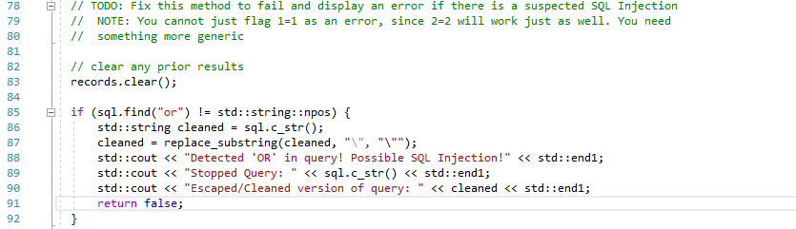

Above is a snapshot of the section of coding that I added. I am having trouble though; my code is correct I ran the debug program, and it says that there are no errors. I press Ctrl + F5 but nothing happens. Is there something that I missed?

Below are snapshots of all the coding in order.

